Question 1
What is a variable in C/C++?
Ans: variable is a named storage location in the computer's memory used to hold data that a program can manipulate

- Why do we use variables in programs?
- Ans: variables are used as named containers to temporarily store, manipulate, and retrieve data within a computer's memory during a program's execution

- What is the difference between a variable name and its value?
- Ans: The variable name is the identifier, while the value is the actual data stored in it.

- Which of the following is a valid variable name? a) 2num b) total_marks c) for d) my marks
- Ans: b) total_marks

- Why is Age different from age?
- Ans: C++ is case-sensitive, so Age and age are different variables

- Can a variable name contain spaces? Why?
- Ans: No. Variable names cannot contain spaces.

- Can a variable name start with an underscore (_) ?
- Ans: Yes , variable names can start with an underscore . example: _count

- What happens if two variables have the same name in the same scope?
- Ans: The compiler generates an error because variable names must be unique within the same
- scope

- Write three meaningful variable names for storing student information.
- ANS : studentName, studentAge, studentMarks

- Which naming convention is better and why: studentMarks or sm?
- Ans: studentMarks because it is descriptive and easy to understand

- What is a data type?
- Ans A data type specifies the kind of data a variable can store.

- Which data type is used to store whole numbers?
- Ans : int

- Which data type is used to store decimal values?
- Ans: float or double

- What is the difference between float and double?
- Ans: double provides greater precision than float.

- Which data type stores a single character?
- Ans: char

- Which data type stores True/False values?
- Ans: bool

- What data type is suitable for storing a person's name?
- Ans: string

- Predict the output: int age=18; cout<<age;
- Ans: 18

- Identify the data type: 25, 3.14, 'A', true.
- Ans: 25=int, 3.14=double, 'A'=char, true=bool

- What happens if you store a decimal number in an int variable?
- Ans: The decimal part is discarded. Example:
3.14 becomes 3

- What is the purpose of cin?
- Ans: cin is used to take input from the user

- What is the purpose of cout?
- Ans: cout is used to display output on the screen.

- Which symbol is used with cin?
- Ans: >>

- Which symbol is used with cout?
- Ans: <<

- Explain: cin >> age;
- Ans:It takes input from the user and stores it in age.

- Explain: cout << age;
- Ans: It displays the value of age

- What is the purpose of endl?
- Ans: endl moves the cursor to the next line.

- Write a statement to input a student's marks.
- Ans: cin >> marks;

- Write a statement to display 'Welcome to C++’.
- Ans: cout << "Welcome to C++";

- Predict the output: cout << 'Programming’;
- Ans: Error because single quotes are for a single character.

- What is an operator?
- Ans: An operator is a symbol that performs an operation on operands

- Which operator is used for addition?
- Ans:+

- What is the result of 10 % 3?
- Ans: 1
Explanation: The %(modulus)operator gives the remainder after division.
10 % 3 = 1
Because: 10/3=3 remainder 1.

- What is the result of 8 % 2?
- Ans:0
- Because:8 is completely divisible by 2,so remainder is 0.

- Which operator checks equality?
- Ans:==

- What is the difference between = and == ?
- Ans:= assigns a value, while == compares two values.

- What is the result of 5 > 3?
- Ans:True

- What does && represent?
- Ans: Logical AND operator.It returns true only when both conditions are true.

- What does || represent?
- Ans: Logical OR operator.It returns true if at least one condition is true .

- What does ! represent?
- Ans: Logical NOT operator.It reverses the result of a condition.

Question 41
- Write a program to print”Hello world”?
- Problem Statement:
- Write a program to display”Hello world “ on screen.
- Algorithm: 1. start the program.
- Display “Hello world” using cout3.
- End the program.
- C++ Program #include<iostream> using namespace std; int main()
{
cout<<“Hello world”;
return 0;
}
- Explanation :
- #include <iostream>: used for input/output operations
- using namespace std; → Allows use of cout without std::

- cout → Displays output on screen
- return 0; → Ends the program successfully
- Output
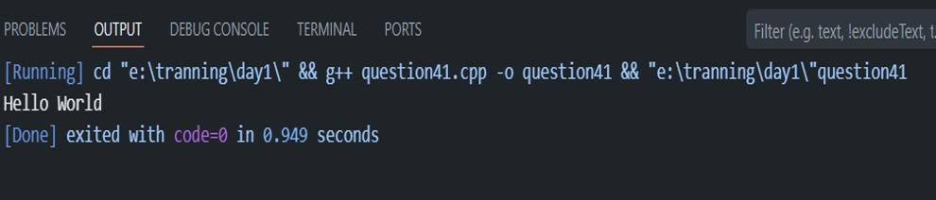

Question 42
- Write a program to input two numbers and display their sum.
- Problem Statement
- Write a program to take two numbers from the user and display their sum.
- Algorithm
  - Start the program
  - Declare two variables
  - Take input from user
  - Add both numbers
  - Display the result
  - End the program
- C++ Program #include<iostream> Using namespace std; int main()
{
int num1,num2,sum;

cout<<“enter first number:”;
cin>>num1; sum=num1 +num2; cout<<“sum=“<<sum; Return 0;
}
Explanation

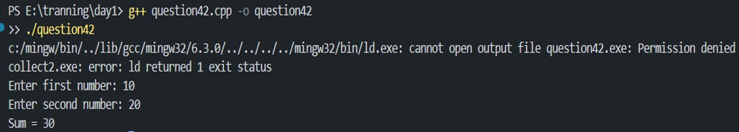

Question 43
- Write a program to calculate the area of a rectangle.
- Problem Statement
Write a program to calculate the area of a rectangle.
- Formula:
Area = Length × Breadth
- Algorithm
- Start the program
- Declare variables for length and breadth
- Take input from user
- Calculate area
- Display area
- End the program C Pgrogram #include<stdio.h>
int main()
{

float length, breadth, area; printf("Enter length: "); scanf("%f", &length); printf("Enter breadth: "); scanf("%f", &breadth); area = length * breadth;
printf("Area of Rectangle = %.2f", area); return 0;
}
Explanation
- scanf() takes input
- length * breadth calculates area
- printf() displays output
- %.2f shows decimal values up to 2 places
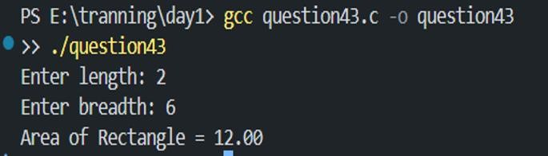

Question 44
- What formula is used to calculate Simple Interest?
- Ans:The formula used to calculate Simple Interest (SI) is:
SI = P*R*T/100
Where:
- P = Principal Amount
- R = Rate of Interest
- T = Time
- SI = Simple Interest

Question 45
Write a program to calculate Simple Interest.
- Problem Statement
Write a program to calculate Simple Interest using principal, rate, and time.
- Algorithm
- Start the program
- Declare variables
- Take principal, rate, and time as input
- Apply formula
- Display result
- End the program C Program #include<stdio.h>
int main()
{
Float principal,rate,time,SI; printf(“enter principal amont:”); scanf(“%f”,&principal);

printf("Enter Rate of Interest: "); scanf("%f", &rate); printf("Enter Time: "); scanf("%f", &time);
SI = (principal * rate * time) / 100; printf("Simple Interest = %.2f", SI); return 0;
}
Explanation
- User enters principal amount, rate, and time
- Formula is applied to calculate simple interest
- Result is displayed using printf()
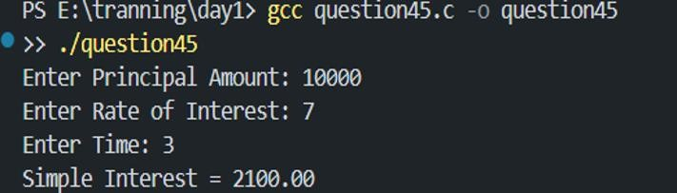

Question 46
- Why is a temporary variable used while swapping two numbers?
- Ans : A temporary variable is used to safely store one value while swapping two numbers so that the original value is not lost.

Question 47
Swap the values: a=10, b=20
- Problem Statement
Write a program to swap two numbers using a temporary variable.
- Algorithm
- Start the program
- Declare variables a, b, and temp
- Store value of a in temp
- Assign value of b to a
- Assign value of temp to b
- Display swapped values
- End the program C++ Program #include<iostream.h> Using namespace std; int main()
{
int a=10,b=20,temp;

cout << "Before Swapping:" << endl; cout << "a = " << a << endl;
cout << "b = " << b << endl; temp = a;
a = b;
b = temp;
cout << "After Swapping:" << endl; cout << "a = " << a << endl;
cout << "b = " << b << endl; return 0;
}
Explanation
- temp = a stores value of a
- a = b copies value of b into a
- b = temp restores original value of a into b
- This swaps both numbers successfully
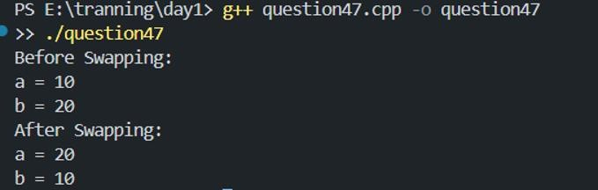

- What formula is used to convert Celsius into Fahrenheit?
- Ans: F=9/5C+32
- Explanation:
C= temperature in Celsius
F= temperature in fahrenheit

- What is the Fahrenheit value of 0°C?
- Ans: using the formula F=9/5C+32 Where C = 0°c

Calculation:
F = (9/5 × 0) + 32 F = 32°F
- Final Answer:
The Fahrenheit value of 0°C is 32°F.

Question 50
Why can integer division give incorrect results in the Celsius-to-Fahrenheit program?
Answer
Integer division can give incorrect results because integers remove the decimal part.
For example:
5 / 9
This becomes:
0
instead of:
0.555...
So, if integer division is used in the Celsius-to-Fahrenheit formula, the answer may become wrong.
Correct Way
Use float or double for accurate decimal calculations.

